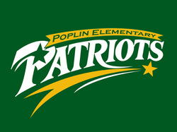

What is the PTA?
What exactly does the PTA do? The PTA (Parent Teacher Association) supports Poplin Elementary in many ways. Through monetary support and volunteerism, we have been able to provide many things over the past few years including:
Building and Grounds:
- Purchased and installed fence
- Purchased and installed swing sets
- Purchased basketball goals
- Purchased basketballs
- Purchased 2 picnic tables
- Purchased planters for the entryway and flowers

Inside the School:
- Purchased laptop computer cart
Financial Support for:
- Terrific Kids
- Teacher Academic Enrichment Support
Staff Events:
- Staff Breakfasts
- Staff Holiday Luncheon
- Staff Appreciation Week
- Wonderful Wednesday Luncheons
Special Events:
- 5th Grade Dance and Graduation
- Muffins for Mom
- Donuts with Dad
- Spring Festival
- Holiday Store
When you join the PTA and help us with our fundraising, you are helping to provide all of this and more to our school. Thank you for your support!

